Testing table V2
Changes made: Added range checking inside the method.
Input | Expected output | Actual output | Passed?
17, 61, 51, 28, 76 – Valid results | Average score: 53.6%  Smallest score: 19.5%  Largest score: 87.4%  Total amount of scores: 5  Scores, sorted smallest to largest:  19.5%  32.2%  58.6%  70.1%  87.4% | 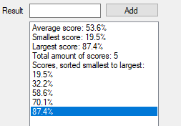 | Y
88 – Out of range | Please enter a number between 0 and 87 inclusive! Message box. | 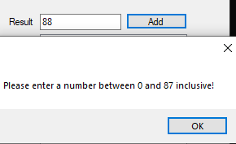 | Y
-1 – Out of range | Please enter a number between 0 and 87 inclusive! Message box. |  | Y
Ten – Invalid data | Crash | 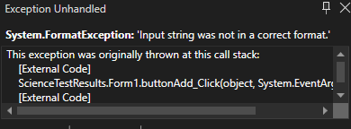 | N
Show results pressed with no data | No results to show! Message box. | 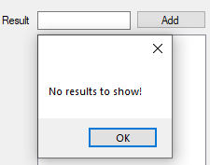 | Y
87 – Highest acceptable number | Average score: 100%  Smallest score: 100%  Largest score: 100%  Total amount of scores: 1  Scores, sorted smallest to largest:  100% | 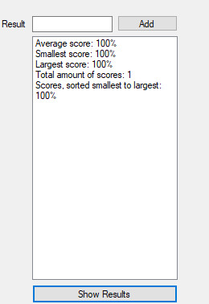 | Y
20.5 – Non int score | Crash | 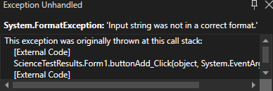 | N
0 – Lowest acceptable number | Average score: 0%  Smallest score: 0%  Largest score: 0%  Total amount of scores: 1  Scores, sorted smallest to largest:  0% | 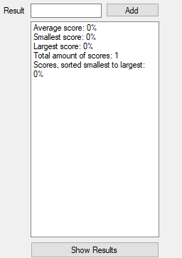 | Y

